DATABASE MANAGEMENT
SYSTEMS LAB

REPORT ASSIGNMENT-4

NAME: SOHAM LAHIRI

CLASS: BCSE UG-III 6TH SEMESTER

ROLL NO: 002210501107

GROUP: A3

SUBMISSION DATE: 16/04/2025

Problem Statement 5:
Consider the tables that you have designed for problem 5 of Assignment 3. Write down the PL/SQL blocks for the following:
- Book issue with proper validation of member, availability of book and eligibility check for issue.
- Book return with proper check (whether this copy was issued to this member or not).

Entity-Relationship Diagram:
MEMBER TYPE INFO
MEMBER
TRANSACTION
BOOK
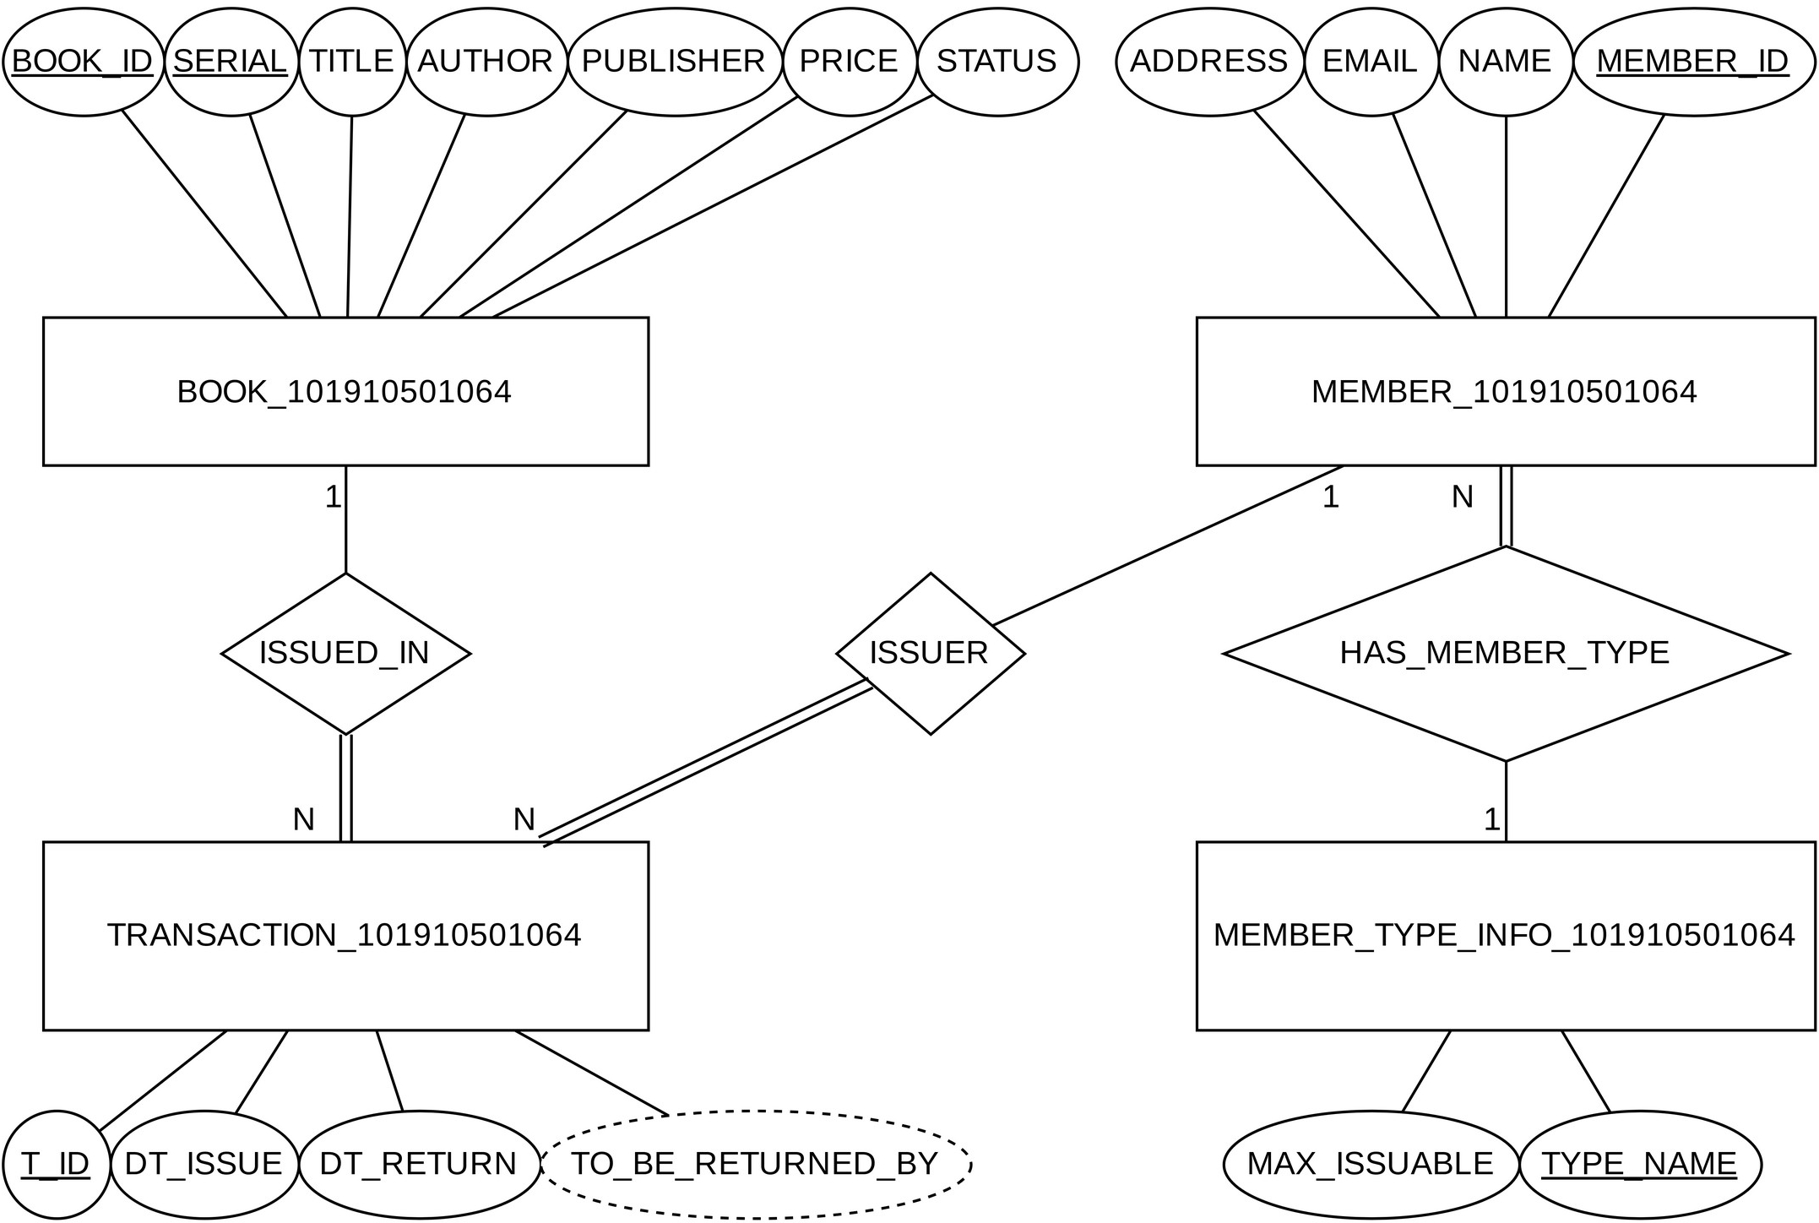

SQL Table Creation Code³:
Creating BOOK:
CREATE TABLE BOOK(
BOOK_ID CHAR(15),
SERIAL INTEGER,
TITLE CHAR(31), AUTHOR CHAR(31), PUBLISHER CHAR(31), PRICE NUMBER,
STATUS CHAR(15) DEFAULT 'Available',
CONSTRAINT BOOK_PK PRIMARY KEY(BOOK_ID, SERIAL), CONSTRAINT STATUS_RANGE CHECK(STATUS IN ('Issued', 'Available'))
); COMMIT;

Creating insertion trigger to create proper serial number for BOOK:
CREATE OR REPLACE TRIGGER BOOK_INSERT_TRIGGER BEFORE INSERT ON BOOK
FOR EACH ROW BEGIN
IF :NEW.SERIAL IS NOT NULL THEN GOTO BOOK_INSERT_END; END IF;

SELECT MAX(BOOK.SERIAL) + 1 INTO :NEW.SERIAL FROM BOOK
WHERE BOOK.BOOK_ID = :NEW.BOOK_ID;

IF :NEW.SERIAL IS NULL THEN :NEW.SERIAL := 1; END IF;

DBMS_OUTPUT.PUT_LINE('New Serial Number: '||:NEW.SERIAL);

<<BOOK_INSERT_END>> NULL;
END;
COMMIT;

Creating MEMBER_TYPE_INFO AND MEMBER:
CREATE TABLE MEMBER_TYPE_INFO ( TYPE_NAME CHAR(31),
MAX_ISSUABLE INTEGER,
CONSTRAINT MEMBER_TYPE_INFO_PK PRIMARY KEY(TYPE_NAME)
);
CREATE TABLE MEMBER( MEMBER_ID CHAR(15),
NAME CHAR(31), EMAIL CHAR(63), ADDRESS CHAR(31),
MEMBER_TYPE CHAR(31),
CONSTRAINT MEMBER_PK PRIMARY KEY(MEMBER_ID), CONSTRAINT MEMBER_TYPE_REFERENCE
FOREIGN KEY (MEMBER_TYPE)
REFERENCES MEMBER_TYPE_INFO(TYPE_NAME)
); COMMIT;

Creating TRANSACTION:
CREATE TABLE TRANSACTION(
T_ID INTEGER, MEMBER_ID CHAR(15), BOOK_ID CHAR(15), SERIAL INTEGER,
DT_ISSUE DATE DEFAULT SYSDATE, TO_BE_RETURNED_BY
GENERATED ALWAYS AS (DT_ISSUE + 7) VIRTUAL,
DT_RETURN DATE,
CONSTRAINT TRANSACTION_PK PRIMARY KEY(T_ID), CONSTRAINT MEMBER_REFERENCE
FOREIGN KEY (MEMBER_ID)
REFERENCES MEMBER(MEMBER_ID), CONSTRAINT BOOK_REFERENCE
FOREIGN KEY (BOOK_ID, SERIAL)
REFERENCES BOOK(BOOK_ID, SERIAL),
CONSTRAINT DT_RETURN_RANGE CHECK (DT_RETURN IS NULL OR DT_RETURN >= DT_ISSUE)
);
COMMIT;

Creating stored procedure for issuing books:
CREATE PROCEDURE BOOKISSUE (
--Member ID to issue book to (input parameter) IN_MEMBER_ID IN MEMBER.MEMBER_ID%TYPE,
--Book ID to issue (input parameter) IN_BOOK_ID IN BOOK.BOOK_ID%TYPE,
--Serial number of copy issued (output value) OUT_BOOK_SERIAL OUT BOOK.SERIAL%TYPE,
--Generated transaction ID (output value) OUT_T_ID OUT TRANSACTION.T_ID%TYPE
) AS
BEGIN
OUT_BOOK_SERIAL := NULL; OUT_T_ID := NULL;

DECLARE
L_MAX_ISSUABLE INTEGER; L_CUR_ISSUED INTEGER; L_MEMBER_ID MEMBER.MEMBER_ID%TYPE; L_BOOK_EXISTS BOOLEAN := FALSE;
BEGIN
--Valid member ID?
BEGIN
SELECT MM.MEMBER_ID INTO L_MEMBER_ID FROM MEMBER MM WHERE MM.MEMBER_ID = IN_MEMBER_ID;
EXCEPTION
WHEN NO_DATA_FOUND THEN
RAISE_APPLICATION_ERROR(-20000, 'No member with ID '||IN_MEMBER_ID); GOTO ISSUE_END;
END;

--Valid book ID?
BEGIN
SELECT (COUNT(BK.BOOK_ID) > 0) INTO L_BOOK_EXISTS FROM BOOK BK WHERE BK.BOOK_ID = IN_BOOK_ID;
EXCEPTION
WHEN NO_DATA_FOUND THEN L_BOOK_EXISTS := FALSE;
END;

IF NOT L_BOOK_EXISTS THEN
RAISE_APPLICATION_ERROR(-20000, 'No book with ID '||IN_BOOK_ID); GOTO ISSUE_END;
END IF;

--Can we issue book?
SELECT TPI.MAX_ISSUABLE INTO L_MAX_ISSUABLE
FROM MEMBER_TYPE_INFO TPI, MEMBER MM
WHERE TPI.TYPE_NAME = MM.MEMBER_TYPE AND MM.MEMBER_ID = IN_MEMBER_ID;

SELECT COUNT(*) INTO L_CUR_ISSUED FROM TRANSACTION TR
WHERE TR.DT_RETURN IS NULL AND TR.MEMBER_ID = IN_MEMBER_ID;

IF L_CUR_ISSUED >= L_MAX_ISSUABLE THEN
RAISE_APPLICATION_ERROR(-20000, 'Already max issued!'); GOTO ISSUE_END;
END IF;
END;

--Is there even an available book? BEGIN
SELECT T_SERIAL INTO OUT_BOOK_SERIAL FROM (
SELECT BK.SERIAL T_SERIAL FROM BOOK BK
WHERE BK.BOOK_ID = IN_BOOK_ID AND BK.STATUS = 'Available' ORDER BY BK.SERIAL ASC
) WHERE ROWNUM <= 1; EXCEPTION
WHEN NO_DATA_FOUND THEN
RAISE_APPLICATION_ERROR(-20000, 'No more books available!'); GOTO ISSUE_END;
END;
DBMS_OUTPUT.PUT_LINE('BOOK.SERIAL issued := '||OUT_BOOK_SERIAL);

--Assign OUT_T_ID
SELECT MAX(TRANSACTION.T_ID) + 1 INTO OUT_T_ID FROM TRANSACTION;

IF SQL%NOTFOUND OR OUT_T_ID IS NULL THEN OUT_T_ID := 1; END IF;
DBMS_OUTPUT.PUT_LINE('TRANSACTION_10191051064.T_ID := '||OUT_T_ID);

--Insert into transaction
INSERT INTO TRANSACTION (T_ID, MEMBER_ID, BOOK_ID, SERIAL) VALUES (OUT_T_ID, IN_MEMBER_ID, IN_BOOK_ID, OUT_BOOK_SERIAL);

--Update in book
UPDATE BOOK BK SET BK.STATUS = 'Issued'
WHERE BK.BOOK_ID = IN_BOOK_ID AND BK.SERIAL = OUT_BOOK_SERIAL;

<<ISSUE_END>> NULL;
END;
COMMIT;

Creating stored procedure for returning books:
CREATE PROCEDURE BOOKRETURN (
--Member ID of the one returning book (input parameter) IN_MEMBER_ID IN MEMBER.MEMBER_ID%TYPE,
--Book ID of the book being returned (input parameter) IN_BOOK_ID IN BOOK.BOOK_ID%TYPE,
--Serial number copy of the book being returned (input parameter) IN_BOOK_SERIAL IN BOOK.SERIAL%TYPE,
--Transaction ID of the transaction that was updated (output value) OUT_T_ID OUT TRANSACTION.T_ID%TYPE
)
AS BEGIN
BEGIN
SELECT TEMP_T_ID INTO OUT_T_ID FROM (
SELECT TR.T_ID TEMP_T_ID FROM TRANSACTION TR WHERE TR.MEMBER_ID = IN_MEMBER_ID
AND TR.BOOK_ID = IN_BOOK_ID AND TR.SERIAL = IN_BOOK_SERIAL AND TR.DT_RETURN IS NULL
ORDER BY TR.DT_ISSUE DESC, TR.T_ID DESC
) WHERE ROWNUM <= 1; EXCEPTION
WHEN NO_DATA_FOUND THEN
RAISE_APPLICATION_ERROR(-20000, 'Not ever issued!'); GOTO BOOKRETURN_END;
END;
DBMS_OUTPUT.PUT_LINE('TRANSACTION.T_ID := '||OUT_T_ID);

--Update in transaction
UPDATE TRANSACTION TR SET TR.DT_RETURN = SYSDATE WHERE TR.T_ID = OUT_T_ID;

--Update in book
UPDATE BOOK BK SET BK.STATUS = 'Available'
WHERE BK.BOOK_ID = IN_BOOK_ID AND BK.SERIAL = IN_BOOK_SERIAL;

<<BOOKRETURN_END>> NULL;
END;
COMMIT;

Inserting values

MEMBER_TYPE_INFO:
INSERT INTO MEMBER_TYPE_INFO VALUES('Student', 2);
INSERT INTO MEMBER_TYPE_INFO VALUES('Faculty', 5);
COMMIT;

MEMBER:
INSERT INTO MEMBER VALUES
('M001', 'Soham Lahiri', 'xyz@gmail.com', 'Durgapur', 'Student');
INSERT INTO MEMBER VALUES
('M002', 'ABCD EFGH', 'abcd@example.com', 'Kolkata', 'Faculty');
INSERT INTO MEMBER VALUES
('M003', 'IJKL MNOP', 'ijkl@ju.in', 'Ranaghat', 'Faculty'); COMMIT;

BOOK:
INSERT INTO BOOK (BOOK_ID, TITLE, AUTHOR, PUBLISHER, PRICE)
VALUES ('B001', 'Introduction to Algorithms', 'Cormen', 'MIT Press', 1200); INSERT INTO BOOK (BOOK_ID, TITLE, AUTHOR, PUBLISHER, PRICE)
VALUES ('B001', 'Introduction to Algorithms', 'Cormen', 'MIT Press', 1256); INSERT INTO BOOK (BOOK_ID, TITLE, AUTHOR, PUBLISHER, PRICE)
VALUES ('B001', 'Introduction to Algorithms', 'Cormen', 'MIT Press', 1190); INSERT INTO BOOK (BOOK_ID, TITLE, AUTHOR, PUBLISHER, PRICE)
VALUES ('B001', 'Introduction to Algorithms', 'Cormen', 'MIT Press', 1200); INSERT INTO BOOK (BOOK_ID, TITLE, AUTHOR, PUBLISHER, PRICE)
VALUES ('B001', 'Introduction to Algorithms', 'Cormen', 'MIT Press', 1245); INSERT INTO BOOK (BOOK_ID, TITLE, AUTHOR, PUBLISHER, PRICE)
VALUES ('B002', 'C++: The Complete Reference', 'Schildt', 'McGraw-Hill', 700);
INSERT INTO BOOK (BOOK_ID, TITLE, AUTHOR, PUBLISHER, PRICE)
VALUES ('B002', 'C++: The Complete Reference', 'Schildt', 'McGraw-Hill', 600); INSERT INTO BOOK (BOOK_ID, TITLE, AUTHOR, PUBLISHER, PRICE)
VALUES ('B002', 'C++: The Complete Reference', 'Schildt', 'McGraw-Hill', 800); INSERT INTO BOOK (BOOK_ID, TITLE, AUTHOR, PUBLISHER, PRICE)
VALUES ('B003', 'Oracle PL/SQL Programming', 'Feuerstein', 'OReilly', 500); INSERT INTO BOOK (BOOK_ID, TITLE, AUTHOR, PUBLISHER, PRICE)
VALUES ('B003', 'Oracle PL/SQL Programming', 'Feuerstein', 'OReilly', 499); INSERT INTO BOOK (BOOK_ID, TITLE, AUTHOR, PUBLISHER, PRICE)
VALUES ('B003', 'Oracle PL/SQL Programming', 'Feuerstein', 'OReilly', 512); INSERT INTO BOOK (BOOK_ID, TITLE, AUTHOR, PUBLISHER, PRICE)
VALUES ('B003', 'Oracle PL/SQL Programming', 'Feuerstein', 'OReilly', 560); INSERT INTO BOOK (BOOK_ID, TITLE, AUTHOR, PUBLISHER, PRICE)
VALUES ('B004', 'Structural Analysis', 'Hibbeler', 'Pearson', 1025); COMMIT;

Outputs:
;
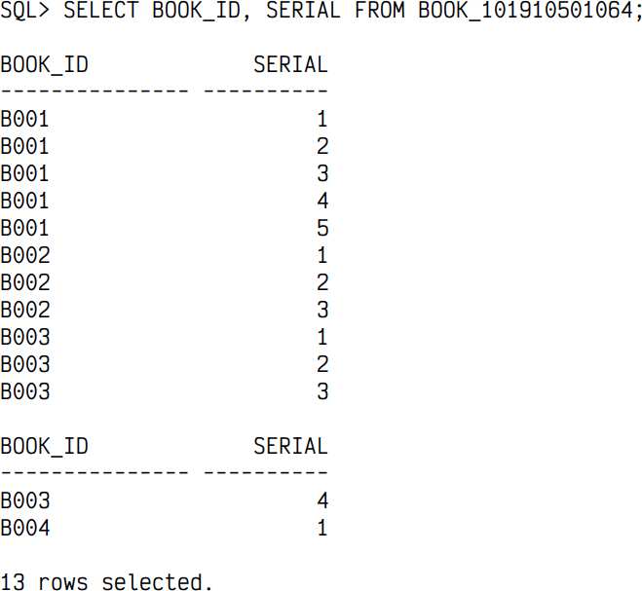

Issuing books successfully (BOOKISSUE):
ORDER BY T_ID;
.SERIAL ISSUED :=1
.T_ID:=3
(‘M002’,’B003’,OUT_SERIAL,OUT_TID);
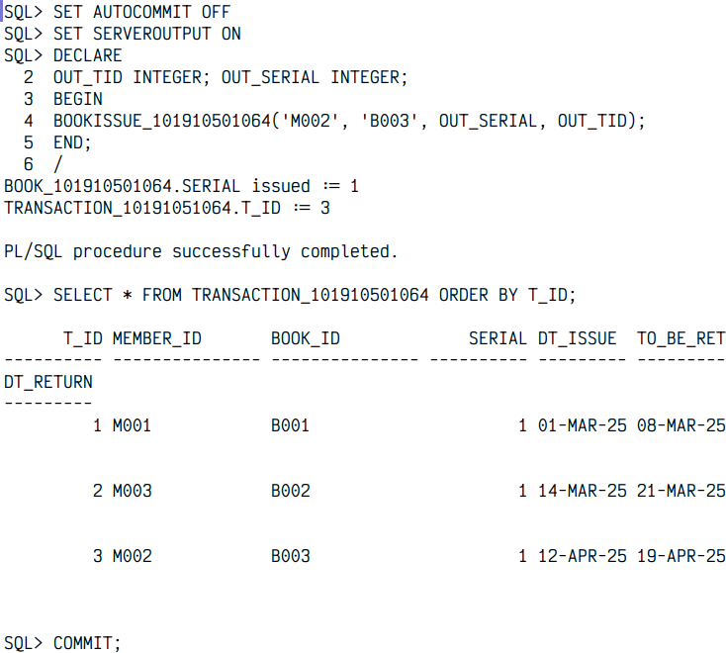
Book doesn’t exist:
“, line 42
(‘M003’,’B012’,OUT_SERIAL,OUT_TID);
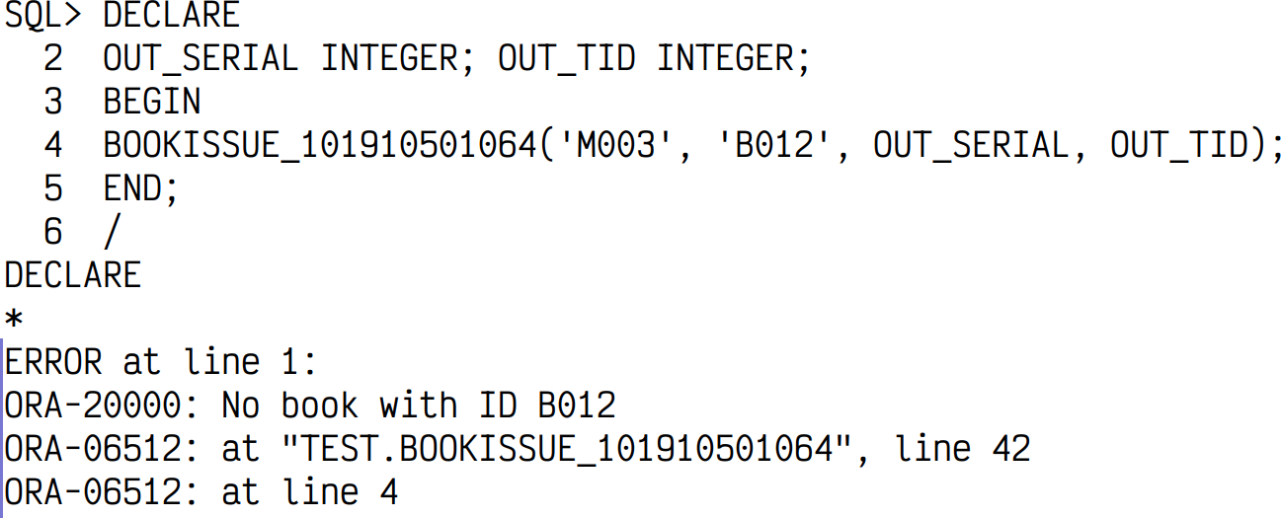

Member doesn’t exist:
“, line 28
(‘M117’,’B001’,OUT_SERIAL,OUT_TID);
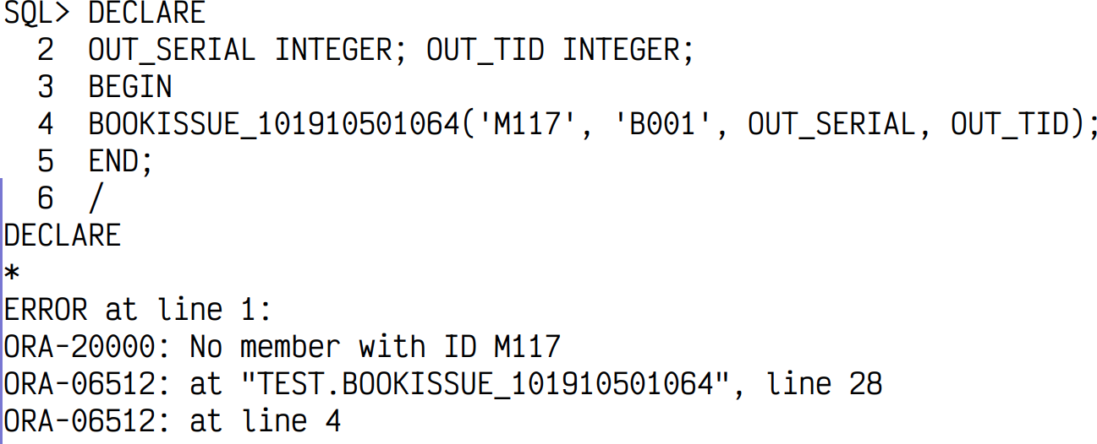
No more books to issue:
“, line 71
(‘M003’,’B004’,OUT_SERIAL,OUT_TID);
.T_ID := 4
.SERIAL issued :=1
(‘M001’,’B004’,OUT_SERIAL,OUT_TID);
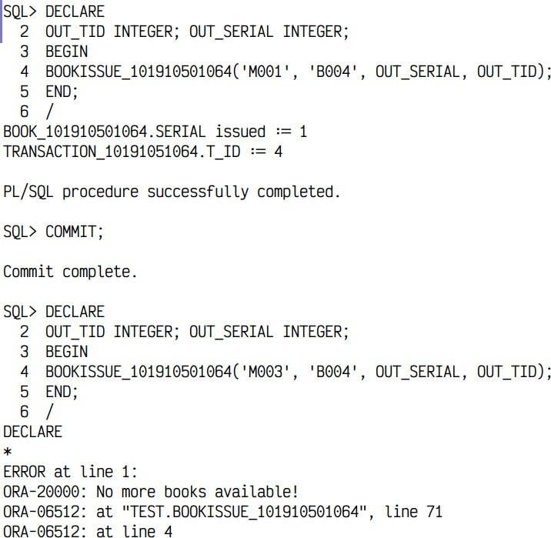

Maximum books issuable simultaneously is limited:

“, line 56
(‘M001’,’B003’,OUT_SERIAL,OUT_TID);
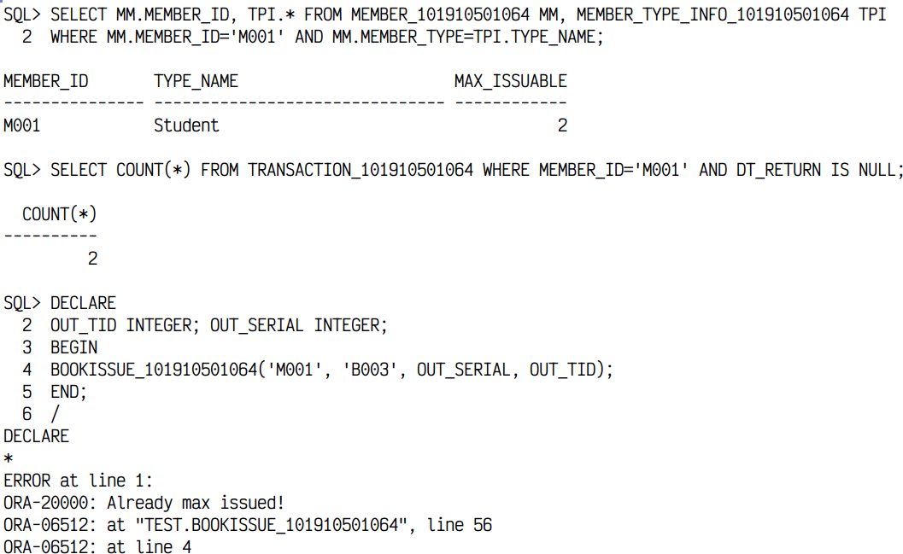

Returning a book (BOOKRETURN):

(‘M001’,’B002’,1,OUT_TID);
.T_ID :=2
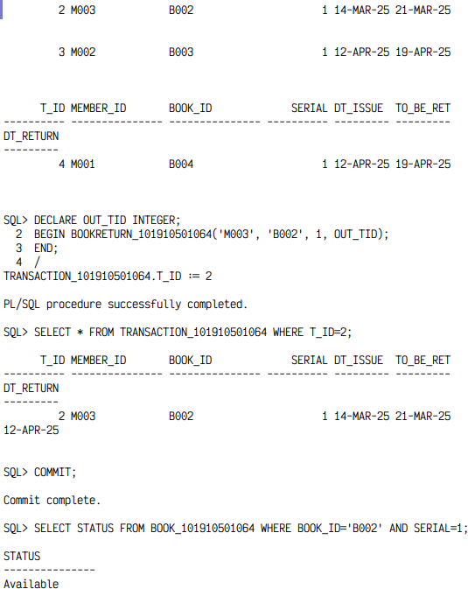
Returning a book that was never issued:
“, line 24
(‘M002’,’B004’,1,OUT_TID);
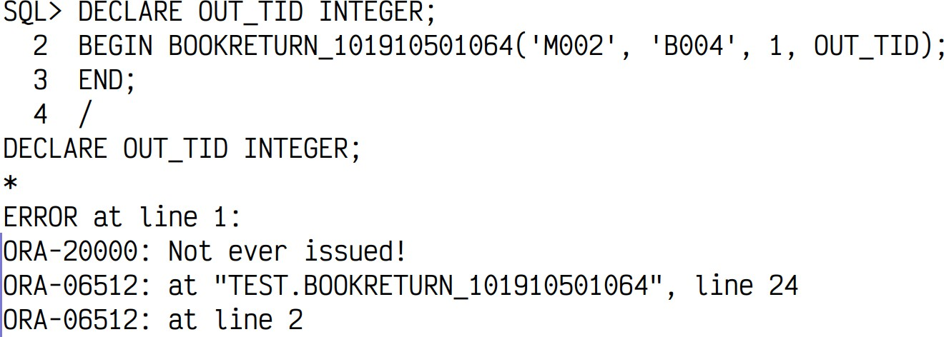

Problem Statement 7:
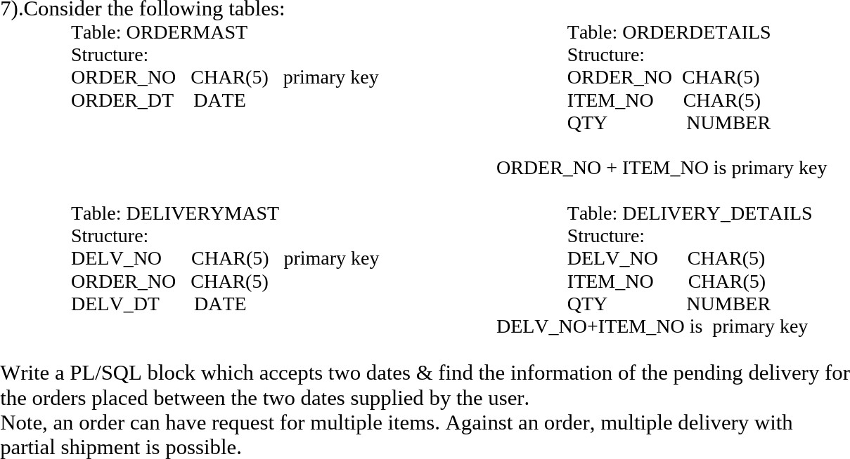

Entity-Relationship Diagram:
DELIVERY_DETAILS
DELIVERYMAST
ORDERDETAILS
ORDERMAST
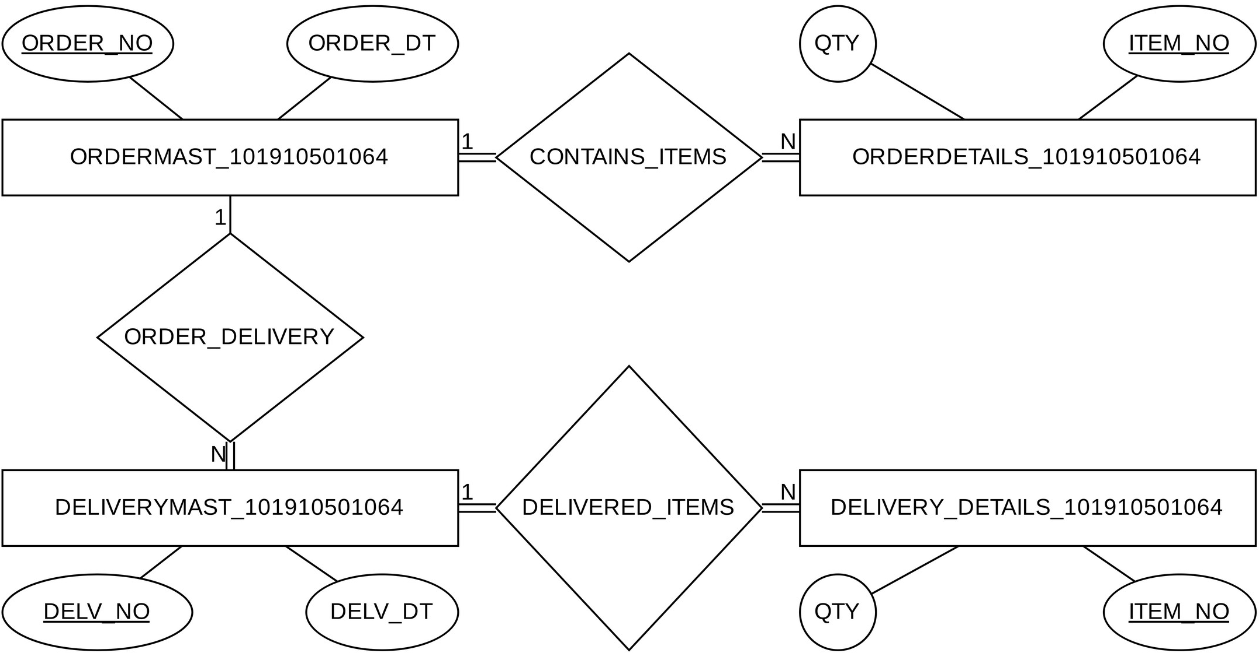
SQL Table Creation Code:
CREATE TABLE ORDERMAST ( ORDER_NO CHAR(5),
ORDER_DT DATE,
CONSTRAINT ORDERMAST_PK PRIMARY KEY (ORDER_NO)
);
INSERT INTO ORDERMAST VALUES ('OD001', '10-JAN-2025');
INSERT INTO ORDERMAST VALUES ('OD002', '15-MAR-2025');

CREATE TABLE ORDERDETAILS ( ORDER_NO CHAR(5),
ITEM_NO CHAR(5), QTY NUMBER,
CONSTRAINT ORDERDETAILS_PK PRIMARY KEY (ORDER_NO, ITEM_NO), CONSTRAINT ORDERDETAILS_MASTER_FK
FOREIGN KEY (ORDER_NO) REFERENCES ORDERMAST (ORDER_NO)
);
INSERT INTO ORDERDETAILS VALUES ('OD001', 'IT001', 5); INSERT INTO ORDERDETAILS VALUES ('OD001', 'IT002', 7); INSERT INTO ORDERDETAILS VALUES ('OD002', 'IT001', 6); INSERT INTO ORDERDETAILS VALUES ('OD002', 'IT003', 3);

CREATE TABLE DELIVERYMAST ( DELV_NO CHAR(5),
ORDER_NO CHAR(5), DELV_DT DATE,
CONSTRAINT DELIVERYMAST_PK PRIMARY KEY (DELV_NO), CONSTRAINT DELIVERYMAST_ORDERMAST_FK
FOREIGN KEY (ORDER_NO) REFERENCES ORDERMAST (ORDER_NO)
);
INSERT INTO DELIVERYMAST VALUES ('D001', 'OD001', '15-FEB-2025'); INSERT INTO DELIVERYMAST VALUES ('D002', 'OD001', '27-FEB-2025'); INSERT INTO DELIVERYMAST VALUES ('D003', 'OD002', '01-APR-2025');

CREATE TABLE DELIVERY_DETAILS ( DELV_NO CHAR(5),
ITEM_NO CHAR(5), QTY NUMBER,
CONSTRAINT DELIVERY_DETAILS_PK PRIMARY KEY (DELV_NO, ITEM_NO), CONSTRAINT DELIVERY_DETAILS_MASTER_FK
FOREIGN KEY (DELV_NO) REFERENCES DELIVERYMAST (DELV_NO)
);
INSERT INTO DELIVERY_DETAILS VALUES ('D001', 'IT001', 2); INSERT INTO DELIVERY_DETAILS VALUES ('D001', 'IT002', 1); INSERT INTO DELIVERY_DETAILS VALUES ('D002', 'IT002', 2); INSERT INTO DELIVERY_DETAILS VALUES ('D003', 'IT003', 3); COMMIT;

Procedure to find pending deliveries between given dates:
CREATE PROCEDURE PENDING_DELIVERIES (
--Input parameters START_DT IN DATE, END_DT IN DATE
) AS
BEGIN
DECLARE
CURSOR ORDERS_LIST IS
SELECT ORD.ORDER_NO AS ORDER_NO, ORD.ORDER_DT AS ORDER_DT FROM ORDERMAST ORD
WHERE (START_DT IS NULL OR ORD.ORDER_DT >= START_DT) AND (END_DT IS NULL OR ORD.ORDER_DT <= END_DT);
ORDERS_RECORD ORDERS_LIST%ROWTYPE;

CURSOR ORDER_ITEMS (IN_ORDER_NO IN ORDERDETAILS.ORDER_NO%TYPE) IS SELECT OD.ITEM_NO AS ITEM_NO, OD.QTY AS QTY
FROM ORDERDETAILS OD WHERE OD.ORDER_NO = IN_ORDER_NO;
ORDER_ITEM_RECORD ORDER_ITEMS%ROWTYPE; DELIVERED_QTY NUMBER;
BEGIN
OPEN ORDERS_LIST;
LOOP
FETCH ORDERS_LIST INTO ORDERS_RECORD; EXIT WHEN ORDERS_LIST%NOTFOUND;
--DBMS_OUTPUT.PUT_LINE('Fetched 1 row ORDERS_RECORD');

OPEN ORDER_ITEMS (ORDERS_RECORD.ORDER_NO); LOOP
FETCH ORDER_ITEMS INTO ORDER_ITEM_RECORD; EXIT WHEN ORDER_ITEMS%NOTFOUND;
--DBMS_OUTPUT.PUT_LINE('Fetched 1 row ORDER_ITEM_RECORD');

DELIVERED_QTY := NULL; BEGIN
SELECT SUM(DD.QTY) INTO DELIVERED_QTY
FROM DELIVERYMAST DM, DELIVERY_DETAILS DD WHERE DM.ORDER_NO = ORDERS_RECORD.ORDER_NO
AND DM.DELV_NO = DD.DELV_NO
AND DD.ITEM_NO = ORDER_ITEM_RECORD.ITEM_NO; EXCEPTION
WHEN NO_DATA_FOUND THEN NULL;
END;
IF DELIVERED_QTY IS NULL THEN DELIVERED_QTY := 0; END IF;

--DBMS_OUTPUT.PUT_LINE('We are reaching here '||DELIVERED_QTY||' '|| ORDER_ITEM_RECORD.QTY);

IF DELIVERED_QTY < ORDER_ITEM_RECORD.QTY THEN
DBMS_OUTPUT.PUT_LINE('Against order '||ORDERS_RECORD.ORDER_NO||' on date '||ORDERS_RECORD.ORDER_DT);
DBMS_OUTPUT.PUT_LINE('For item '||ORDER_ITEM_RECORD.ITEM_NO||', '||
(ORDER_ITEM_RECORD.QTY - DELIVERED_QTY)||' quantity is left undelivered'); DBMS_OUTPUT.PUT_LINE(' ');
END IF;

END LOOP;
CLOSE ORDER_ITEMS; END LOOP;
CLOSE ORDERS_LIST;
END;
END;
Testing PENDING_DELIVERIES:

